Volume
Study Development Factsheet

What is the volume of a shape?
A shape’s volume is how much physical space it takes up, how much material is required to make it, or how much stuff you can fit inside it. There are many real-life situations where calculating volume is useful. For example, the volume inside a drinking glass is the same as how much liquid you can fit in it. Figuring out how much plaster you need to fill a mould is based on the plaster's volume and the mold’s volume.
The way that volume is calculated depends on the properties of the shape.

Prisms
A prism is a three-dimensional shape that has the same cross-section when it is cut in one direction. Think of a Jenga block. If you were to cut it in half, each of the new ends would be a rectangle that is the same size as the original ends of the block. This is the same wherever you cut the block (as long as you cut in the same direction each time). This is the same for cylinders which have a circular cross section (like a tin of beans), triangular prisms (like a Toblerone block), and anything else that is the same shape all the way along.
To find the volume of these shapes:
- Find the area of the cross section.
- Multiply the area by the length of the shape.

Example
Find the volume of this cylinder:
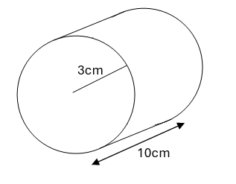

Answer
The area of a circle is given by $πr^{2}$. In this case, $r=3\text{cm}$, so the area of the face is
$$π×\text{3cm}=\text{28.274}{\text{cm}}^{2}$$
To find the volume, this area is multiplied by the length, 10cm:
$$\text{28.274 }{\text{cm}}^{2}×\text{10cm}=\text{282.74}{\text{cm}}^{3}$$
Note: This question could be phrased in other ways. If the cylinder is a glass, we might ask how many cm³ of orange juice we can fit in. If the cylinder was a resin ornament, we could say we need 282.74cm³ of resin to make it.
This method can be used to find the volume of any prism.

Other shapes
There are plenty of other shapes you might want to find the volume of (e.g. a sphere, cone, pyramid etc). These shapes don’t have a uniform way to find their volume, and will each have their own formula, which you can find online. If you are not feeling confident with using formulas, we have some resources available on the YSJ Maths and Statistics Success website.

Example
Find the volume of this cone:
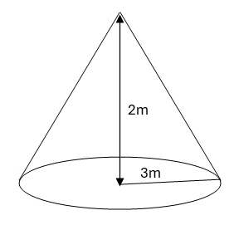

Answer
- Find the formula for the volume online. The volume of a cone is given by $π{\text{r}}^{2}\frac{\text{h}}{\text{3}}$
- Input the values you have.
$$πr^{2}\frac{h}{3}=π×{\left(3\text{m}\right)}^{2}×\frac{2\text{m}}{3}=18.85{\text{m}}^{3}$$

Support: Study Development offers workshops, short courses, 1 to 1 and small group tutorials.
- Book a tutorial or join a workshop on the Study Development tutorial and workshop webpage or search ‘YSJ study development tutorials.’
- Access our Study Success resources on the Study Success webpage or search ‘YSJ study success.’

