Area
Study Development Quick Guide

Rectangles
Area of a rectangle = width $×$ height
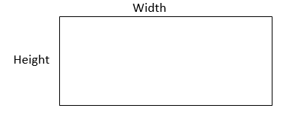

Triangles
Area of a triangle = (base $×$ height) $÷$ 2

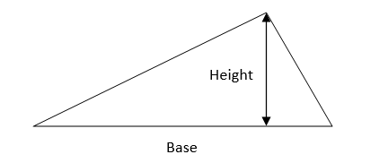

Circles
Area of a circle = $π×{\text{r}}^{2}$
“r” is the radius of the circle (i.e. the length from the centre of the circle to the outside of the circle).
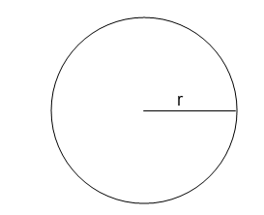

Composite area
Steps:
- Divide the shape into smaller, more familiar shapes.
- Fill in any missing side lengths.
- Find the area of each shape.
- Add the areas together.

Support: Study Development offers workshops, short courses, 1 to 1 and small group tutorials.
- Book a tutorial or join a workshop on the Study Development tutorial and workshop webpage or search ‘YSJ study development tutorials.’
- Access our Study Success resources on the Study Success webpage or search ‘YSJ study success.’

