Exam Revision: Memory and Recall
Study Development Worksheet

Memory and recall technique – Visual Glossary

A glossary can enable you to understand key terms or facts and can be used to help you memorise essential information. It can help you to define something, explain the meaning, and show how it is applied to a scenario or practice.

Step 1. Write down the name of the key term, theory, idea, or technique you need to learn.

Step 2. Beneath the name of your term, draw, sketch, or paste a picture or image that might show or be associated with this.

Step 3. Next to each term, write a short explanation with an example or description of how this idea can be applied in your subject area.

Step 4. Place the visual glossary above your desk or in your revision folder and go through each entry regularly or read each aloud.

Example
Definition of a key term, theory, or idea. | Insert a sketch or image that is associated with this term. | Write a short explanation with an example. | Give an example of how each term can be applied either, in practice, to a process or scenario.
Pathogen | 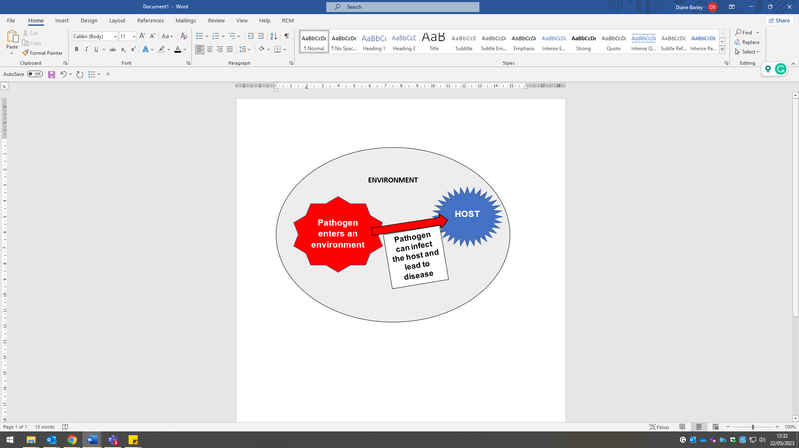 | Is an organism that carries bacteria and viruses that can cause an illness from a cold to a serious disease.  Pathogen carries four types of pathogens; viruses, bacteria, fungi, and protists. | Application - summary of how it can infect humans.  A pathogen can infect a host that will reproduce or replicate the virus and then spread this from the host to other organisms.

My glossary
Write a definition of a key term, theory, or idea. | Insert a sketch or image that is associated with this term. | Write a short explanation with an example. | Give an example of how each term can be applied either, in practice, to a process or scenario.
Define term 1

Define term 2

Define term 3

Define term 4

Define term 5

Support: Study Development offers workshops, short courses, 1 to 1 and small group tutorials.
- Book a tutorial or join a workshop on the Study Development tutorial and workshop webpage or search ‘YSJ study development tutorials.’
- Access our Study Success resources on the Study Success webpage or search ‘YSJ study success.’

