Guide to Microsoft Editor
Study Development Factsheet

Microsoft Editor is an AI-powered service that provides corrections and suggestions for your writing. The advanced features of the functionality are included with your Microsoft 365 subscription. This guide will explain what the service offers, and how you can use it effectively to improve your academic writing.

How do I access the Editor service?
- Go to office.com and login with your YSJ credentials. Then open (or upload) the Word document that you want to work on.
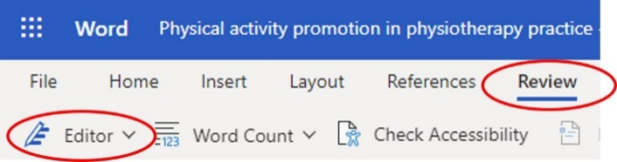
- Once you have opened the Word document in your web browser, click ‘Review’ on the top ribbon, then you will see ‘Editor’ on the far-left side of the screen.
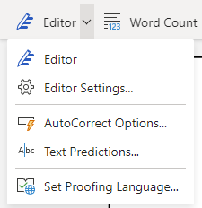
- Click the dropdown symbol to bring up further options. Click ‘Set Proofing Language…’, select ‘Current Document’ and make sure the proofing language is set to ‘English (U.K.)’. Next, click ‘Editor Settings…’ and decide which functionality within Microsoft Editor you want to use for this document. These options are split into Corrections and Refinements, and are explained in further detail below.

Corrections
These options help you to identify Spelling and Grammar mistakes within your writing.
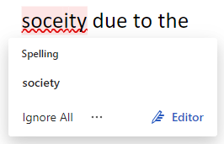
Spelling mistakes appear with a red squiggly line under the word. Clicking on the word brings up a window where you can view the suggested change. You can either click on the suggested word to change it, or click ‘Ignore All’ to keep the original spelling.

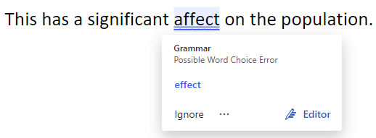
Grammatical errors appear with two solid blue lines under the word(s) concerned. The Editor will give a brief explanation of why it thinks a mistake has been made and will give a suggested correction. Again, you can choose to accept this change by clicking on the suggestion, or click ‘Ignore’.

While this functionality can be extremely helpful when you are proofreading your writing, remember that the service is not perfect – it will not pick up all spelling and grammar mistakes, and sometimes it will identify something as a mistake which is actually correct in the context of your writing. So, you can think of it as a useful tool, but you should not rely on it completely – use your own judgment too!

Refinements
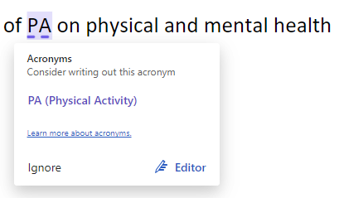
These options provide suggestions for how to make your writing flow better and make it easier for your reader to follow. The highlighted words or phrases are not necessarily grammatically ‘incorrect’, but the software thinks an improvement could be made. This type of suggestion is indicated by a dashed blue line under the relevant word or phrase.
In the example on the right, the Editor suggests writing out an acronym in full the first time it is introduced in the text.

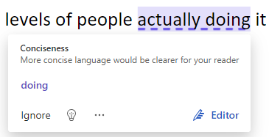
Here, the software suggests removing a word to make the language more concise and therefore clearer for the reader.

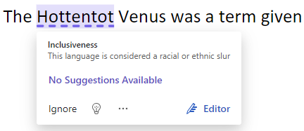
The full list of options included in the Refinements section is as follows: Acronyms, Clarity, Conciseness, Formality, Inclusiveness, Perspectives, Punctuation Conventions, Sensitive Geopolitical References, and Vocabulary. In some cases, such as in the example on the right, the Editor may recommend you edit a sensitive reference or an offensive term. However, clearly you should not remove it if its inclusion is necessary for your work! Again, you should exercise your own judgment and use the software as a tool, alongside our other proofreading resources and the Manchester Academic Phrasebank.

Further Reading
- Microsoft Editor checks grammar and more in documents, mail, and the web

Support: Study Development offers workshops, short courses, 1 to 1 and small group tutorials.
- Book a tutorial or join a workshop on the Study Development tutorial and workshop webpage or search ‘YSJ study development tutorials.’
- Access our Study Success resources on the Study Success webpage or search ‘YSJ study success.’

